End-to-End Composite Solids

Definition
# Source: AI Source: Provided by: [Data Path: Persons Table -> ID Column: 1, Name_En Column: Motasem Essam] -> From: [ChatGPT] on [7/25/2026]
End-to-End Composite Solids are three-dimensional geometric structures formed by connecting two or more solid components consecutively through their end faces or terminal surfaces.
The components are positioned along a common direction, with the end of one component connected to the beginning of another. They may consist of identical solids or different geometric shapes, including cubes, rectangular prisms, cylinders, cones, and other solids.
End-to-end arrangements can be linear, coaxial, aligned, alternating, symmetrical, or irregular.

Simple Definition
# Source: AI Source: Provided by: [Data Path: Persons Table -> ID Column: 1, Name_En Column: Motasem Essam] -> From: [ChatGPT] on [7/25/2026]
An end-to-end composite solid is a three-dimensional structure formed by connecting multiple geometric solids consecutively at their ends.

Geometric Representation
# Source: AI Source: Provided by: [Data Path: Persons Table -> ID Column: 1, Name_En Column: Motasem Essam] -> From: [ChatGPT] on [7/25/2026]
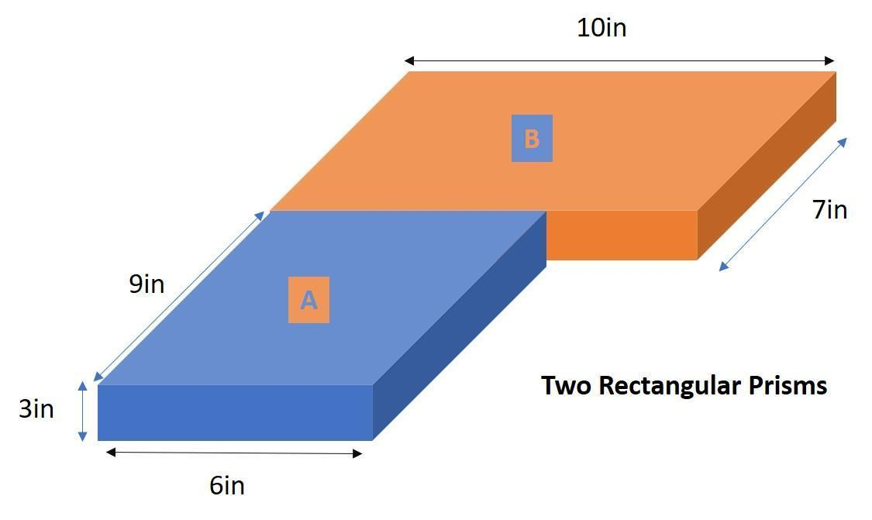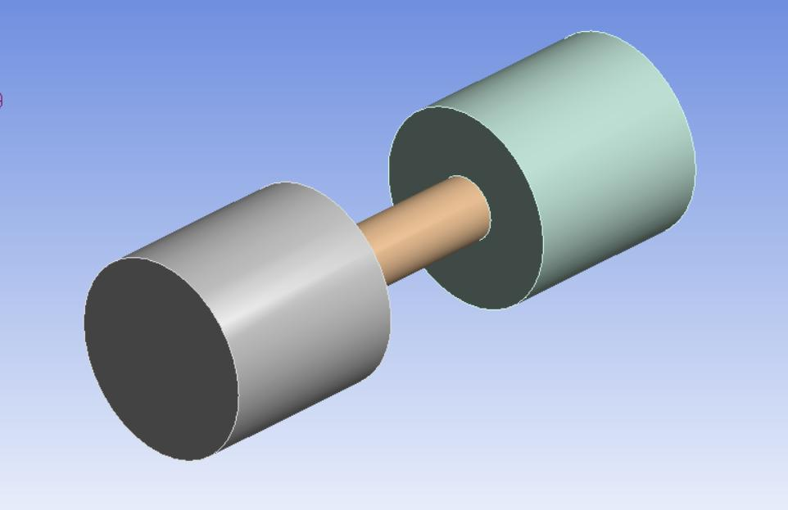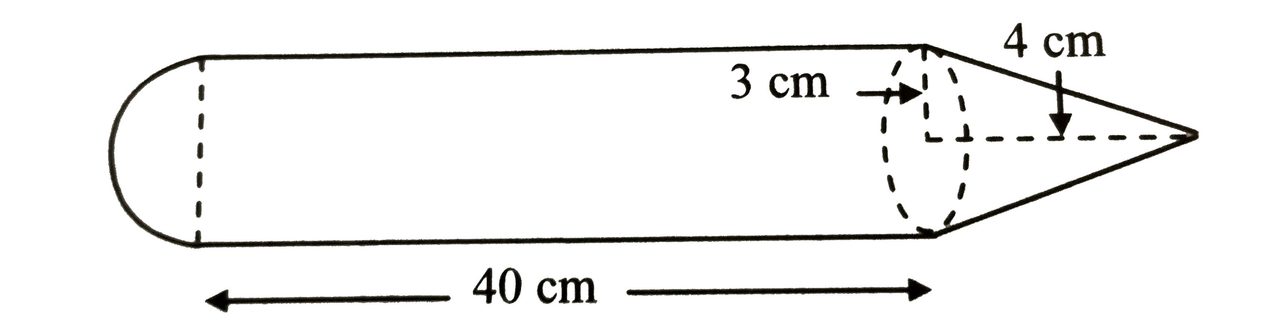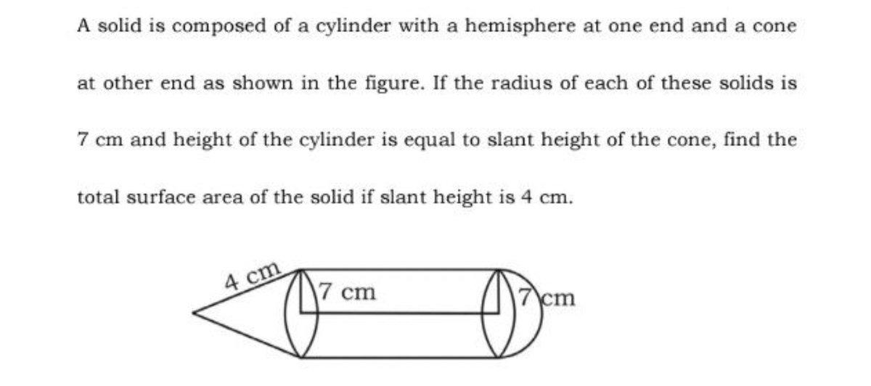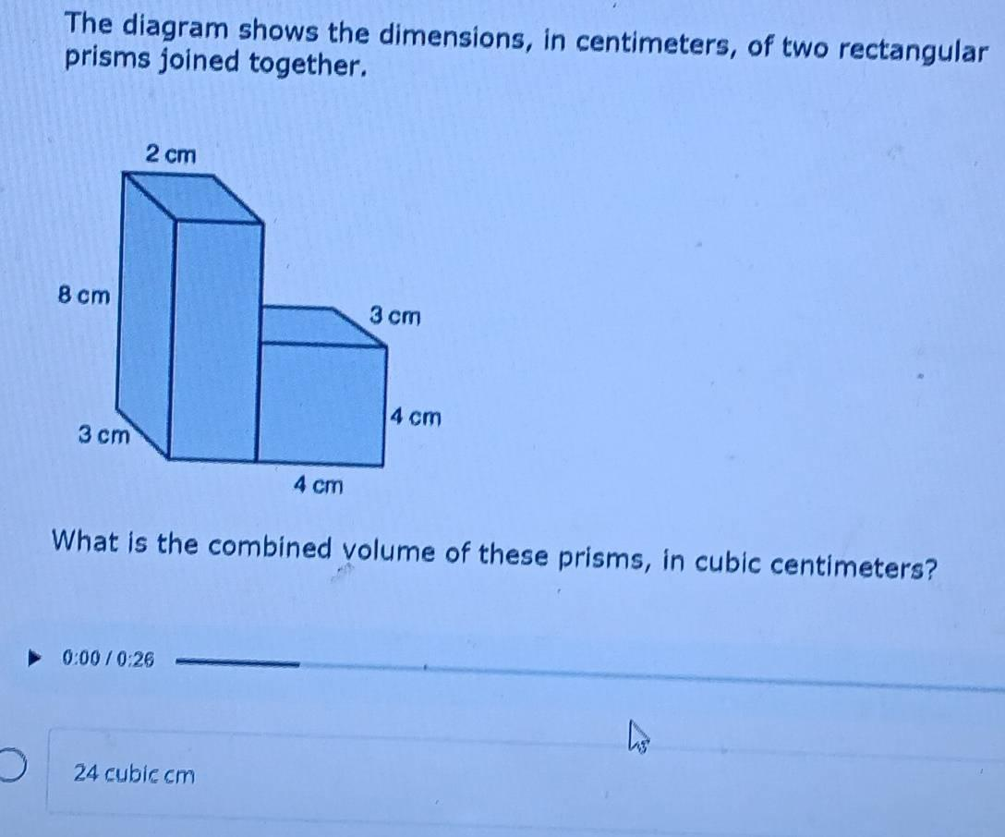
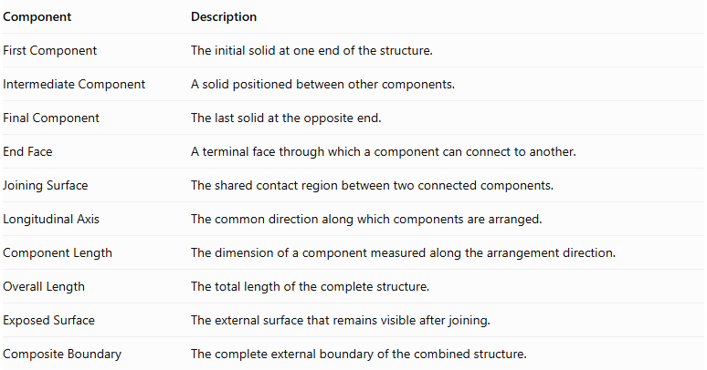
Component | Description
First Component | The initial solid at one end of the structure.
Intermediate Component | A solid positioned between other components.
Final Component | The last solid at the opposite end.
End Face | A terminal face through which a component can connect to another.
Joining Surface | The shared contact region between two connected components.
Longitudinal Axis | The common direction along which components are arranged.
Component Length | The dimension of a component measured along the arrangement direction.
Overall Length | The total length of the complete structure.
Exposed Surface | The external surface that remains visible after joining.
Composite Boundary | The complete external boundary of the combined structure.

Types of End-to-End Composite Solids

Linear End-to-End Composite Solids
# Source: AI Source: Provided by: [Data Path: Persons Table -> ID Column: 1, Name_En Column: Motasem Essam] -> From: [ChatGPT] on [7/25/2026]
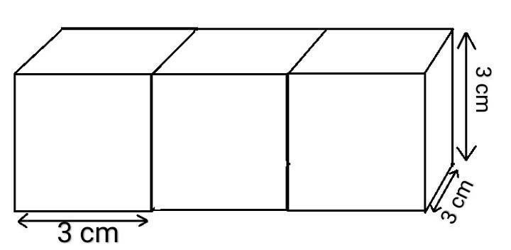
Components connected consecutively along a straight line.
- Each component connects to the next through an end face.
- Components follow one common direction.
- The structure may contain identical or different solids.
- The arrangement forms an elongated composite structure.

Horizontal End-to-End Composite Solids
# Source: AI Source: Provided by: [Data Path: Persons Table -> ID Column: 1, Name_En Column: Motasem Essam] -> From: [ChatGPT] on [7/25/2026]
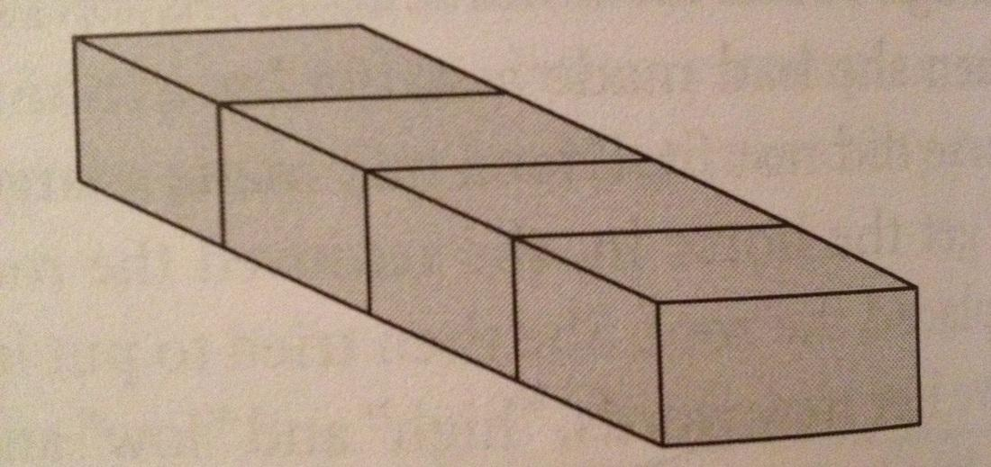
Components connected consecutively along a horizontal direction.
- The longitudinal axis is horizontal.
- Components may have equal or different lengths.
- Their end faces may be aligned or partially connected.

Vertical End-to-End Composite Solids
# Source: AI Source: Provided by: [Data Path: Persons Table -> ID Column: 1, Name_En Column: Motasem Essam] -> From: [ChatGPT] on [7/25/2026]
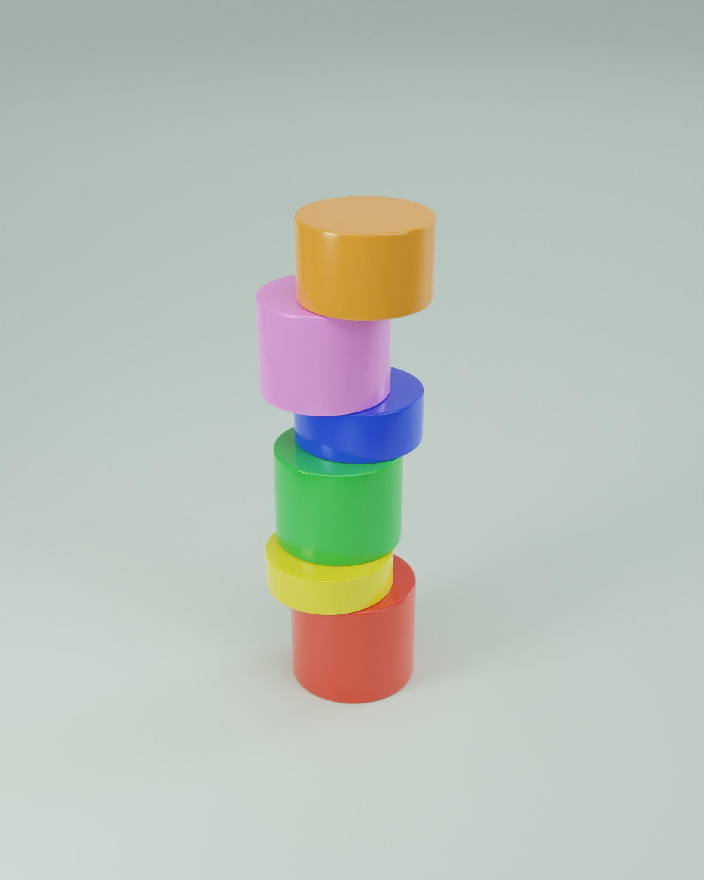
Components connected consecutively along a vertical direction.
- Each component connects to the next through its upper or lower end.
- The arrangement forms a vertical column or tower.
- Components may have equal or different dimensions.

Coaxial End-to-End Composite Solids
# Source: AI Source: Provided by: [Data Path: Persons Table -> ID Column: 1, Name_En Column: Motasem Essam] -> From: [ChatGPT] on [7/25/2026]
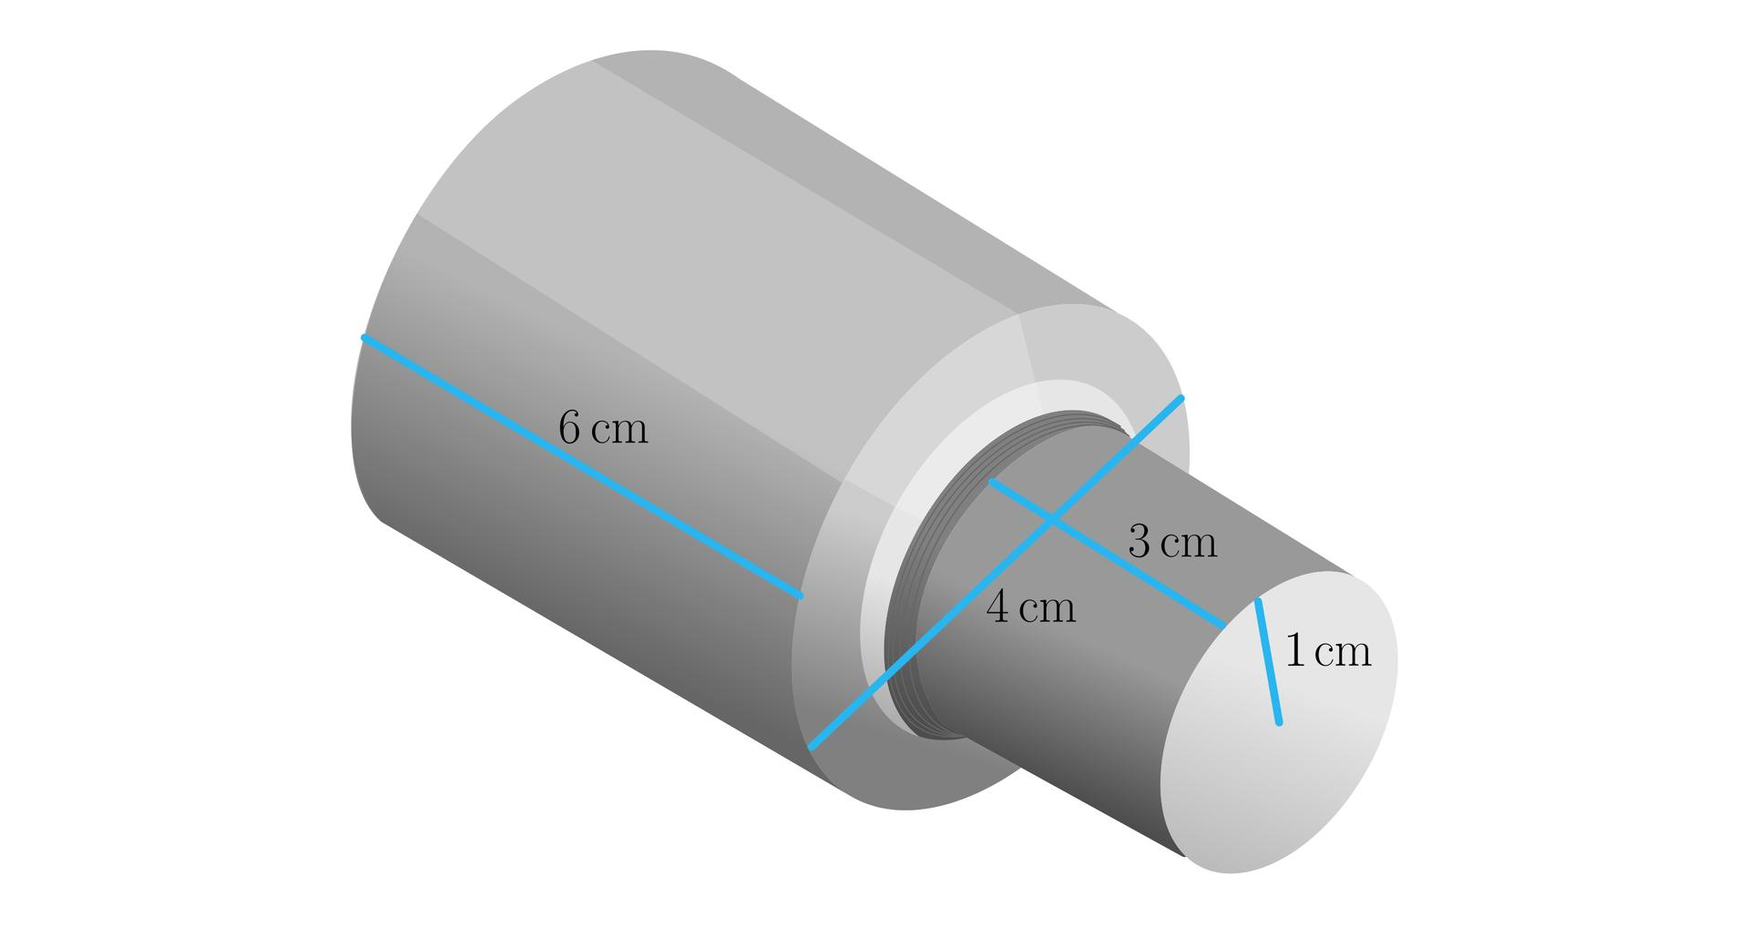
Components connected along a common central axis.
- Commonly used with cylinders and other axisymmetric solids.
- Their central axes coincide.
- Circular end faces may have matching or different radii.
- The structure may have a constant or changing cross-section.

Aligned End-to-End Composite Solids
# Source: AI Source: Provided by: [Data Path: Persons Table -> ID Column: 1, Name_En Column: Motasem Essam] -> From: [ChatGPT] on [7/25/2026]
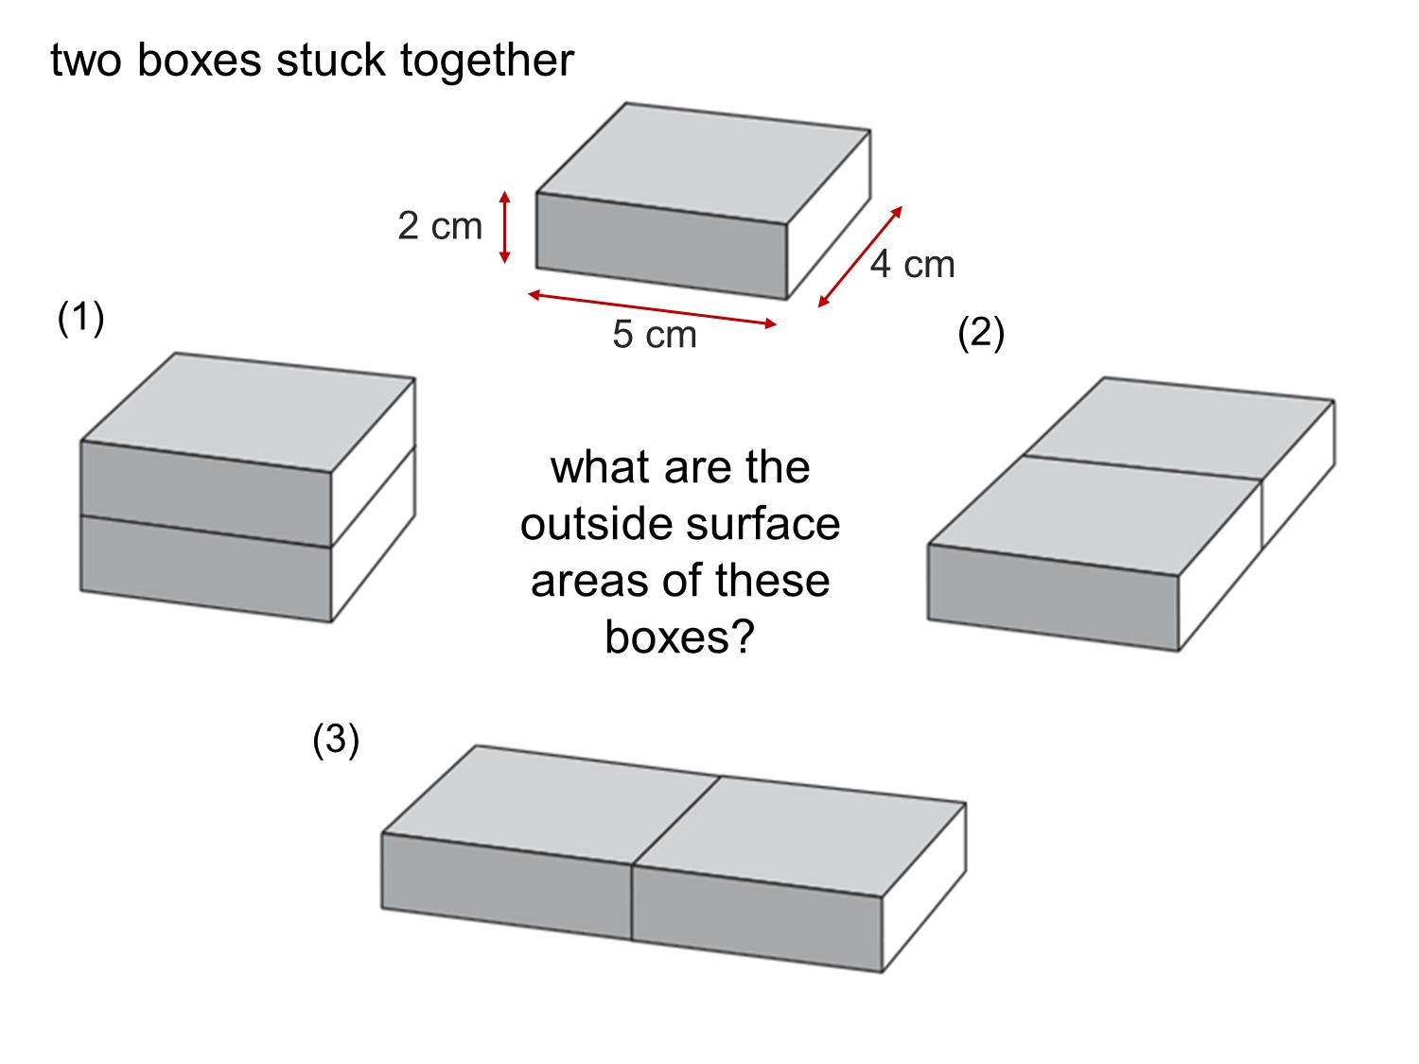
Components connected with corresponding end-face boundaries aligned.
- Matching faces may create a continuous external profile.
- Components may have identical cross-sectional dimensions.
- The resulting structure may resemble one longer solid.

Stepped End-to-End Composite Solids
# Source: AI Source: Provided by: [Data Path: Persons Table -> ID Column: 1, Name_En Column: Motasem Essam] -> From: [ChatGPT] on [7/25/2026]
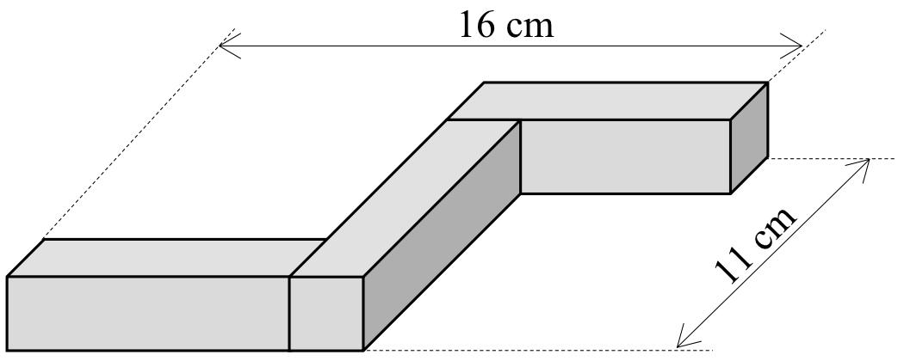
Components connected consecutively with different dimensions or offsets.
- Each component may have a different cross-sectional size.
- The external boundary changes at joining positions.
- The structure can form stepped or irregular profiles.

Alternating End-to-End Composite Solids
# Source: AI Source: Provided by: [Data Path: Persons Table -> ID Column: 1, Name_En Column: Motasem Essam] -> From: [ChatGPT] on [7/25/2026]
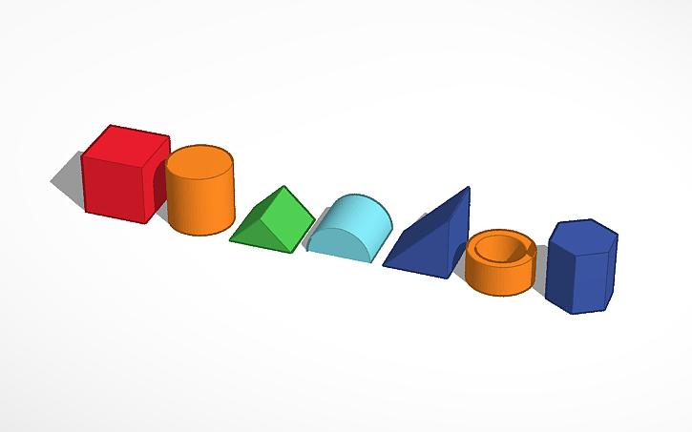
Different types of solids connected in an alternating sequence.
- A cylinder may connect to a prism, followed by a cone.
- Component types may repeat in a regular pattern.
- The structure combines different surface geometries.

Symmetrical End-to-End Composite Solids
# Source: AI Source: Provided by: [Data Path: Persons Table -> ID Column: 1, Name_En Column: Motasem Essam] -> From: [ChatGPT] on [7/25/2026]
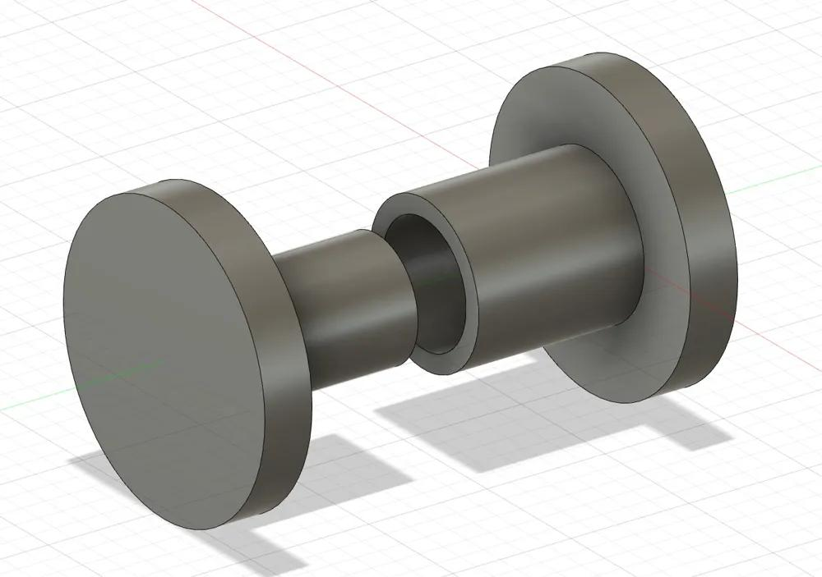
Components arranged around a central component or plane with matching structures on opposite sides.
- Corresponding components may have equal dimensions.
- The structure may have reflectional symmetry.
- Its external shape is balanced around a central position.

Asymmetrical End-to-End Composite Solids
# Source: AI Source: Provided by: [Data Path: Persons Table -> ID Column: 1, Name_En Column: Motasem Essam] -> From: [ChatGPT] on [7/25/2026]
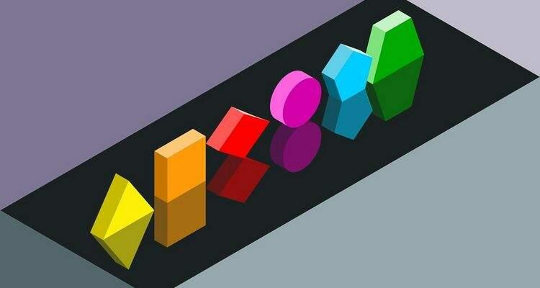
Components connected consecutively without maintaining symmetry.
- Components may have different dimensions.
- Cross-sectional sizes may change irregularly.
- The structure may have an uneven external profile.

Multi-Component End-to-End Composite Solids
# Source: AI Source: Provided by: [Data Path: Persons Table -> ID Column: 1, Name_En Column: Motasem Essam] -> From: [ChatGPT] on [7/25/2026]
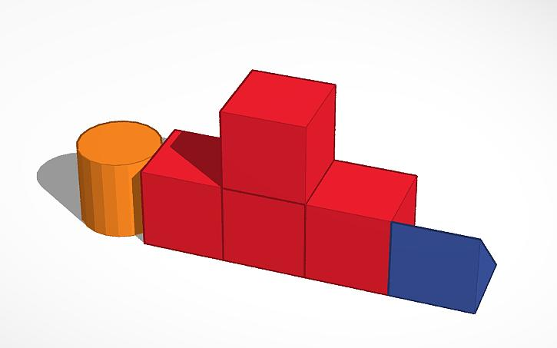
Structures containing three or more components connected consecutively.
- Intermediate components connect neighboring solids.
- Component types and dimensions may vary.
- The structure may contain multiple joining interfaces.

Mixed-Shape End-to-End Composite Solids
# Source: AI Source: Provided by: [Data Path: Persons Table -> ID Column: 1, Name_En Column: Motasem Essam] -> From: [ChatGPT] on [7/25/2026]
Structures formed by connecting different geometric solid categories through their terminal surfaces.
Examples include:
- Rectangular prism–cylinder.
- Cylinder–cone.
- Cylinder–hemisphere.
- Prism–pyramid.
- Multiple mixed-shape sequences.
Important: End-to-end connection requires an actual contact region. For example, a circular cylinder base can connect to a larger rectangular end face through partial planar contact, but the remaining portion of the rectangular face stays exposed.

Classification by Arrangement Direction
# Source: AI Source: Provided by: [Data Path: Persons Table -> ID Column: 1, Name_En Column: Motasem Essam] -> From: [ChatGPT] on [7/25/2026]
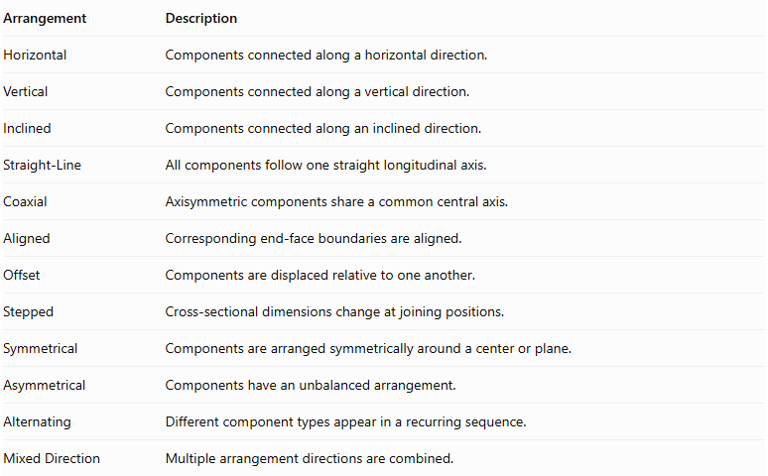
Arrangement | Description
Horizontal | Components connected along a horizontal direction.
Vertical | Components connected along a vertical direction.
Inclined | Components connected along an inclined direction.
Straight-Line | All components follow one straight longitudinal axis.
Coaxial | Axisymmetric components share a common central axis.
Aligned | Corresponding end-face boundaries are aligned.
Offset | Components are displaced relative to one another.
Stepped | Cross-sectional dimensions change at joining positions.
Symmetrical | Components are arranged symmetrically around a center or plane.
Asymmetrical | Components have an unbalanced arrangement.
Alternating | Different component types appear in a recurring sequence.
Mixed Direction | Multiple arrangement directions are combined.

Classification by Component Types

Same-Shape End-to-End Composite Solids
# Source: AI Source: Provided by: [Data Path: Persons Table -> ID Column: 1, Name_En Column: Motasem Essam] -> From: [ChatGPT] on [7/25/2026]
All components belong to the same geometric solid category.
- Cube-Based End-to-End Composite Solids.
- Rectangular Prism-Based End-to-End Composite Solids.
- Triangular Prism-Based End-to-End Composite Solids.
- Cylinder-Based End-to-End Composite Solids.
- Cone-Based End-to-End Composite Solids.
- Pyramid-Based End-to-End Composite Solids.
- Hemisphere-Based End-to-End Composite Solids.

Mixed-Shape End-to-End Composite Solids
# Source: AI Source: Provided by: [Data Path: Persons Table -> ID Column: 1, Name_En Column: Motasem Essam] -> From: [ChatGPT] on [7/25/2026]
Components belong to different geometric solid categories.
- Prism-Cylinder.
- Prism-Cone.
- Prism-Pyramid.
- Cylinder-Cone.
- Cylinder-Hemisphere.
- Cylinder-Frustum.
- Cone-Pyramid.
- Multiple-Shape End-to-End Composite Solids.
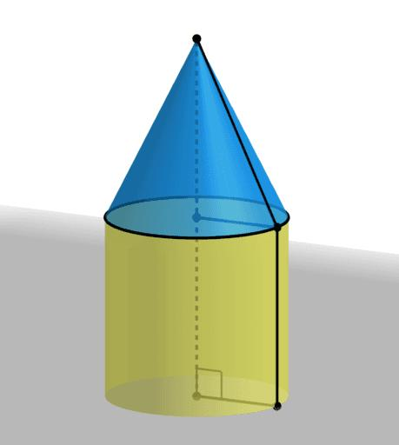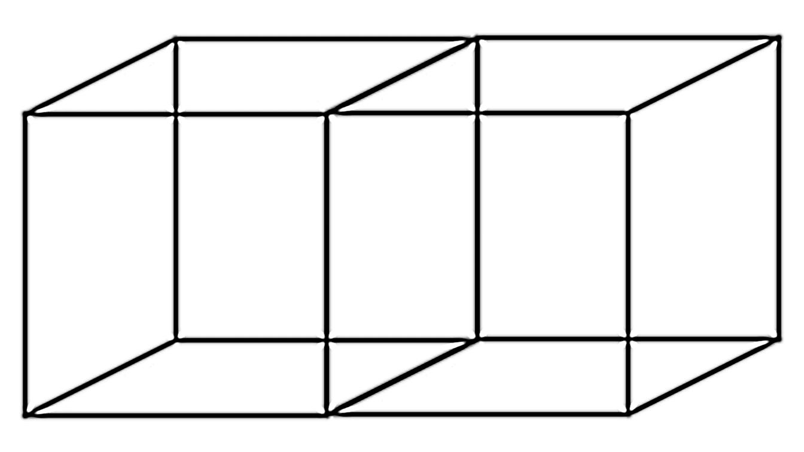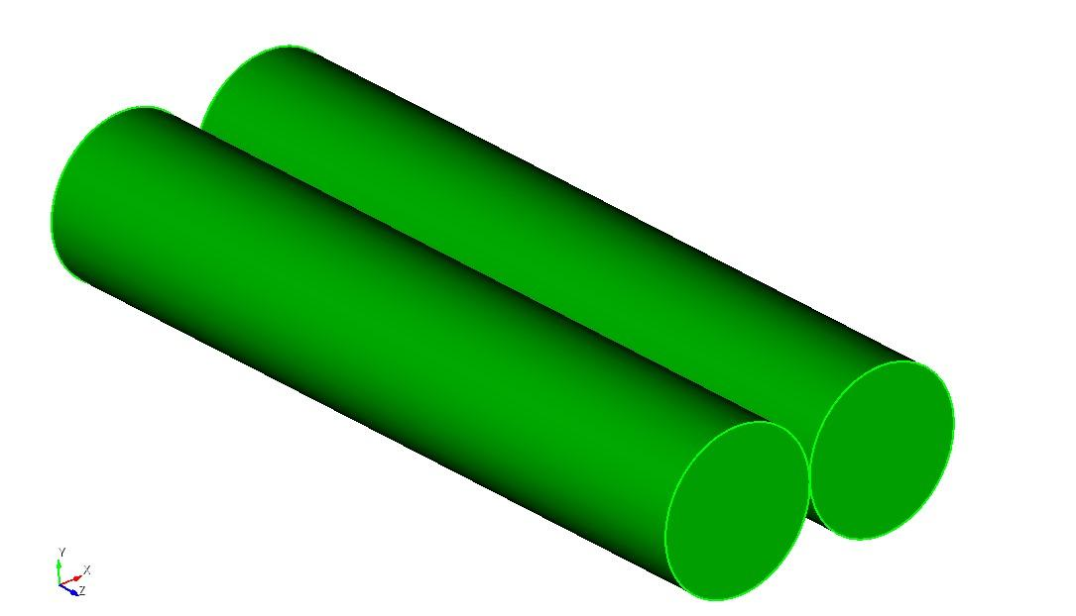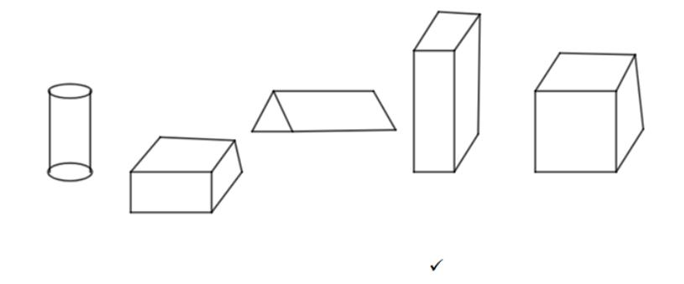

Classification by Joining Surfaces
# Source: AI Source: Provided by: [Data Path: Persons Table -> ID Column: 1, Name_En Column: Motasem Essam] -> From: [ChatGPT] on [7/25/2026]
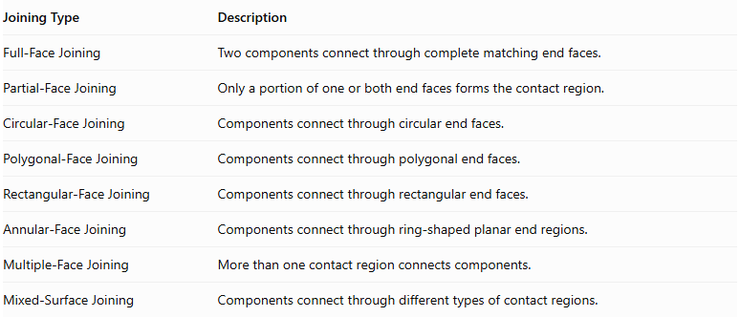
Joining Type | Description
Full-Face Joining | Two components connect through complete matching end faces.
Partial-Face Joining | Only a portion of one or both end faces forms the contact region.
Circular-Face Joining | Components connect through circular end faces.
Polygonal-Face Joining | Components connect through polygonal end faces.
Rectangular-Face Joining | Components connect through rectangular end faces.
Annular-Face Joining | Components connect through ring-shaped planar end regions.
Multiple-Face Joining | More than one contact region connects components.
Mixed-Surface Joining | Components connect through different types of contact regions.

Mathematical Properties and Formulas

Total Volume
# Source: AI Source: Provided by: [Data Path: Persons Table -> ID Column: 1, Name_En Column: Motasem Essam] -> From: [ChatGPT] on [7/25/2026]
When components are connected end-to-end without overlapping interiors, the total volume is the sum of their individual volumes.
$$\boxed{V_{total}=\sum_{i=1}^{n}{V_{i}}}$$
For $n$ identical components:
$$\boxed{V_{total}=nV}$$
For different component types:
$$V_{total}=V_{1}+V_{2}+⋯+V_{n}$$
If components overlap, the overlapping volumes must be accounted for.

Overall Length
# Source: AI Source: Provided by: [Data Path: Persons Table -> ID Column: 1, Name_En Column: Motasem Essam] -> From: [ChatGPT] on [7/25/2026]
For components arranged consecutively along one direction without overlap:
$$\boxed{L_{total}=L_{1}+L_{2}+⋯+L_{n}}$$
For $n$ identical components:
$$\boxed{L_{total}=nL}$$
Where:
- $L_{i}$ = Length of each component along the arrangement direction.
- $n$ = Number of components.

Volume Formulas for Common Components
# Source: AI Source: Provided by: [Data Path: Persons Table -> ID Column: 1, Name_En Column: Motasem Essam] -> From: [ChatGPT] on [7/25/2026]
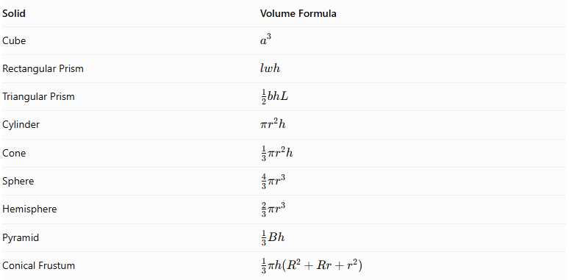
Solid | Volume Formula
Cube | $$a^{3}$$
Rectangular Prism | $$lwh$$
Triangular Prism | $$\frac{1}{2}bhL$$
Cylinder | $$πr^{2}h$$
Cone | $$\frac{1}{3}πr^{2}h$$
Sphere | $$\frac{4}{3}πr^{3}$$
Hemisphere | $$\frac{2}{3}πr^{3}$$
Pyramid | $$\frac{1}{3}Bh$$
Conical Frustum | $$\frac{1}{3}πh(R^{2}+Rr+r^{2})$$

External Surface Area
# Source: AI Source: Provided by: [Data Path: Persons Table -> ID Column: 1, Name_En Column: Motasem Essam] -> From: [ChatGPT] on [7/25/2026]
The external surface area includes all visible surfaces of the combined structure.
For components connected through complete matching planar end faces:
$$\boxed{{SA}_{external}=\sum{{SA}_{i}}-2\sum{A_{contact}}}$$
Where:
- ${SA}_{i}$ = Surface area of each separate component.
- $A_{contact}$ = Area of each complete joining interface.
For partial-face connections:
$${SA}_{external}=\sum{{SA}_{i}}-2\sum{A_{actual contact}}$$
This applies when the contact region is planar and is hidden on both components.
For curved or irregular joining regions, the actual hidden surface regions must be calculated separately.

Surface Area Formulas for Common Components
# Source: AI Source: Provided by: [Data Path: Persons Table -> ID Column: 1, Name_En Column: Motasem Essam] -> From: [ChatGPT] on [7/25/2026]
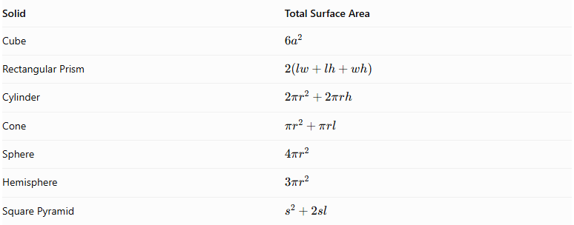
Solid | Total Surface Area
Cube | $$6a^{2}$$
Rectangular Prism | $$2(lw+lh+wh)$$
Cylinder | $$2πr^{2}+2πrh$$
Cone | $$πr^{2}+πrl$$
Sphere | $$4πr^{2}$$
Hemisphere | $$3πr^{2}$$
Square Pyramid | $$s^{2}+2sl$$

Worked Examples

Example 1: Three Rectangular Prisms Connected End-to-End
# Source: AI Source: Provided by: [Data Path: Persons Table -> ID Column: 1, Name_En Column: Motasem Essam] -> From: [ChatGPT] on [7/25/2026]
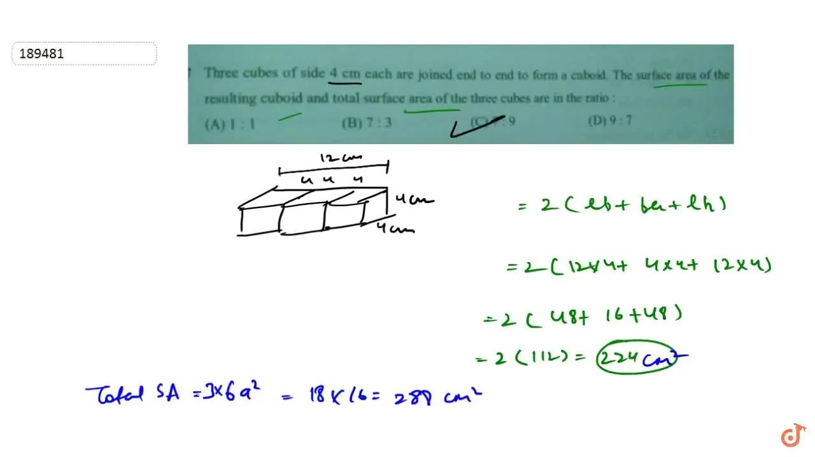
Given:
Three identical rectangular prisms are connected end-to-end through their matching rectangular end faces.
Each prism has:
- Length = $4 cm$
- Width = $3 cm$
- Height = $2 cm$
Step 1: Calculate the volume of one prism.
$$V=lwh$$
$$V=4×3×2$$
$$V=24{ cm}^{3}$$
Step 2: Calculate the total volume.
$$V_{total}=3×24$$
$$\boxed{V_{total}=72{ cm}^{3}}$$
Step 3: Calculate the overall length.
$$L_{total}=3×4$$
$$\boxed{L_{total}=12 cm}$$
Step 4: Calculate the external surface area.
The combined structure forms one rectangular prism with dimensions:
- Length = 12 cm
- Width = 3 cm
- Height = 2 cm
$$SA=2(lw+lh+wh)$$
$$SA=2(12×3+12×2+3×2)$$
$$SA=2(36+24+6)$$
$$\boxed{SA=132{ cm}^{2}}$$
<badge color="success">Final Answer</badge>
- Total Volume = $72{ cm}^{3}$
- Overall Length = $12 cm$
- External Surface Area = $132{ cm}^{2}$

Example 2: A Cylinder and a Cone Connected End-to-End
# Source: AI Source: Provided by: [Data Path: Persons Table -> ID Column: 1, Name_En Column: Motasem Essam] -> From: [ChatGPT] on [7/25/2026]
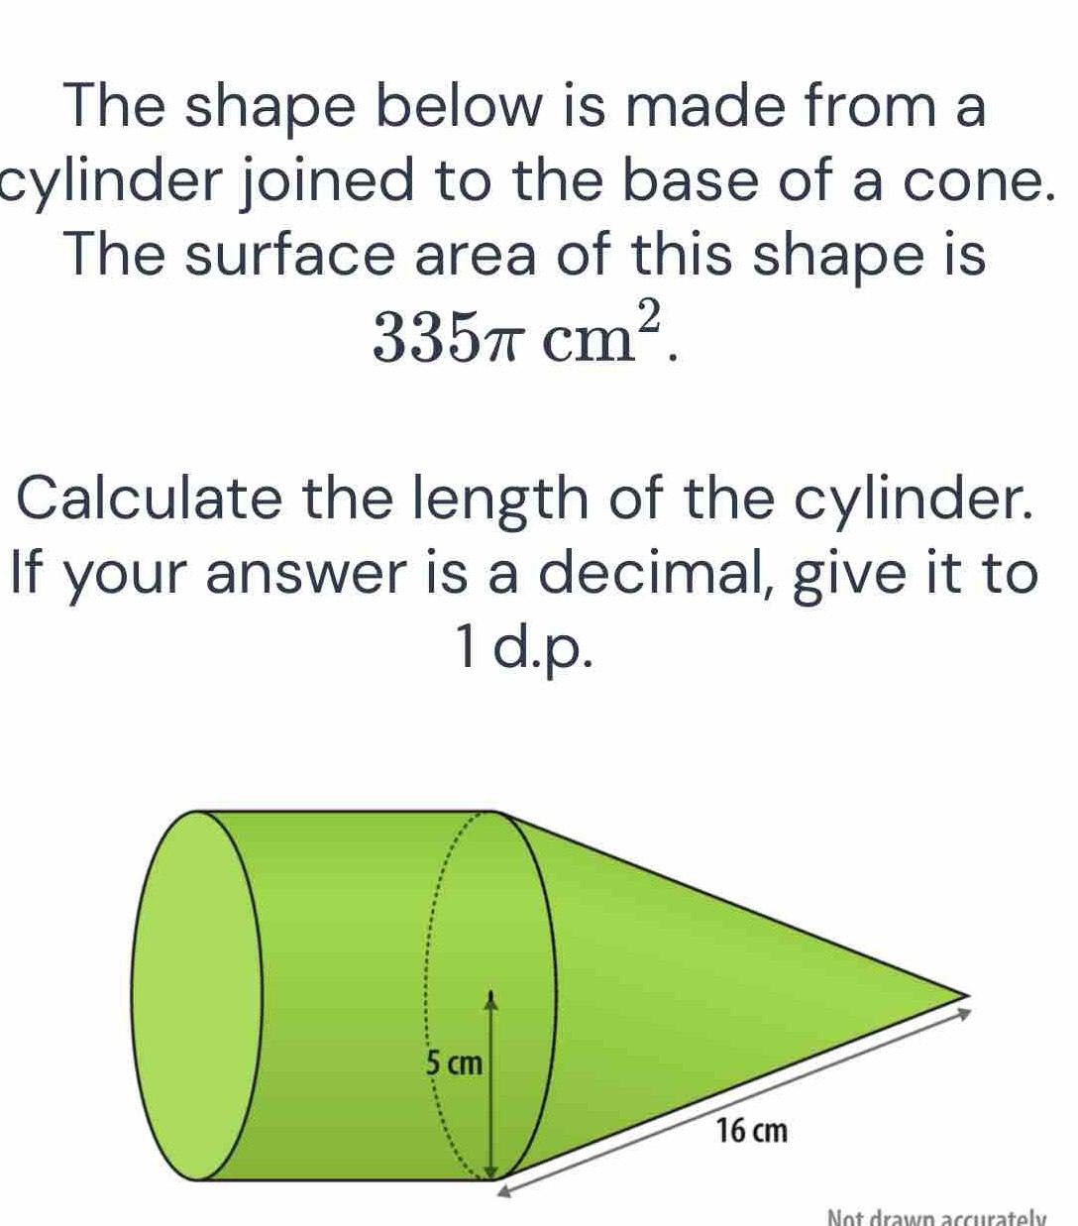
A cylinder is connected to a cone through their matching circular bases.
Given:
Cylinder:
- Radius = $3 cm$
- Height = $6 cm$
Cone:
- Radius = $3 cm$
- Height = $4 cm$
Both components share the same central axis.
Step 1: Calculate the cylinder volume.
$$V_{1}=πr^{2}h$$
$$V_{1}=π(3)^{2}(6)$$
$$V_{1}=54π{ cm}^{3}$$
Step 2: Calculate the cone volume.
$$V_{2}=\frac{1}{3}πr^{2}h$$
$$V_{2}=\frac{1}{3}π(3)^{2}(4)$$
$$V_{2}=12π{ cm}^{3}$$
Step 3: Calculate the total volume.
$$V_{total}=54π+12π$$
$$\boxed{V_{total}=66π≈207.35{ cm}^{3}}$$
Step 4: Calculate the overall length along the common axis.
$$L_{total}=6+4$$
$$\boxed{L_{total}=10 cm}$$
Step 5: Calculate the external surface area.
Cylinder curved surface area:
$${CSA}_{1}=2πrh$$
$${CSA}_{1}=2π(3)(6)=36π$$
Cone slant height:
$$l=\sqrt{r^{2}+h^{2}}$$
$$l=\sqrt{3^{2}+4^{2}}=5$$
Cone curved surface area:
$${CSA}_{2}=πrl$$
$${CSA}_{2}=π(3)(5)=15π$$
The shared circular joining bases are hidden. The bottom circular base of the cylinder remains exposed.
$${SA}_{external}=36π+15π+9π$$
$$\boxed{{SA}_{external}=60π≈188.50{ cm}^{2}}$$
<badge color="success">Final Answer</badge>
- Total Volume = $66π≈207.35{ cm}^{3}$
- Overall Length = $10 cm$
- External Surface Area = $60π≈188.50{ cm}^{2}$

Important Characteristics
# Source: AI Source: Provided by: [Data Path: Persons Table -> ID Column: 1, Name_En Column: Motasem Essam] -> From: [ChatGPT] on [7/25/2026]
- Components are connected consecutively through their terminal regions.
- The arrangement follows a common longitudinal direction.
- Components may be identical or different geometric solid types.
- The structure may be horizontal, vertical, or inclined.
- Components may have matching or different cross-sectional dimensions.
- Joining surfaces may be complete or partial.
- The overall length is determined by the combined component lengths along the arrangement direction.
- Total volume is the sum of component volumes when there is no overlap.
- External surface area excludes hidden joining regions.
- The structure may have a constant, stepped, or changing cross-section.

Comparison with Other Composite Solids by Component Arrangement
# Source: AI Source: Provided by: [Data Path: Persons Table -> ID Column: 1, Name_En Column: Motasem Essam] -> From: [ChatGPT] on [7/25/2026]
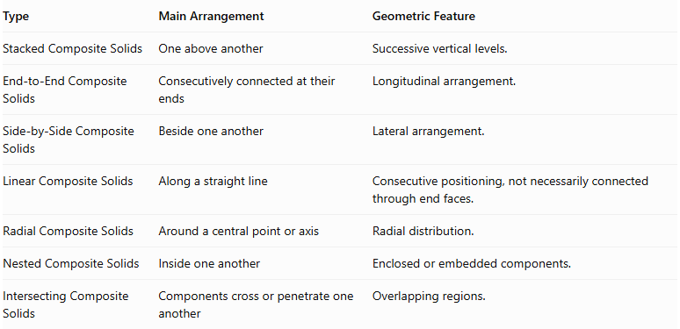
Type | Main Arrangement | Geometric Feature
Stacked Composite Solids | One above another | Successive vertical levels.
End-to-End Composite Solids | Consecutively connected at their ends | Longitudinal arrangement.
Side-by-Side Composite Solids | Beside one another | Lateral arrangement.
Linear Composite Solids | Along a straight line | Consecutive positioning, not necessarily connected through end faces.
Radial Composite Solids | Around a central point or axis | Radial distribution.
Nested Composite Solids | Inside one another | Enclosed or embedded components.
Intersecting Composite Solids | Components cross or penetrate one another | Overlapping regions.

Applications
# Source: AI Source: Provided by: [Data Path: Persons Table -> ID Column: 1, Name_En Column: Motasem Essam] -> From: [ChatGPT] on [7/25/2026]
- Mechanical Engineering: Shafts, connected cylindrical parts, and mechanical assemblies.
- Construction: Connected structural sections and elongated building components.
- Architecture: Repeated horizontal or vertical structural elements.
- Manufacturing: Products assembled from consecutive components.
- Transportation: Connected vehicle sections and modular structural units.
- Industrial Design: Long composite housings and modular products.
- Computer Graphics: Modeling connected geometric sequences.
- Mathematics Education: Studying volume, surface area, alignment, and three-dimensional arrangements.

Key Points
# Source: AI Source: Provided by: [Data Path: Persons Table -> ID Column: 1, Name_En Column: Motasem Essam] -> From: [ChatGPT] on [7/25/2026]
- End-to-end composite solids consist of two or more solids connected consecutively through their ends.
- Components may be identical or different geometric shapes.
- Common arrangements include linear, horizontal, vertical, coaxial, aligned, stepped, alternating, and symmetrical.
- End faces may connect through complete or partial contact regions.
- Overall length is the sum of component lengths when arranged consecutively without overlap.
- Total volume is the sum of component volumes when their interiors do not overlap.
- External surface area includes only exposed surfaces.
- Hidden joining regions must be excluded from external surface-area calculations.

Conclusion
# Source: AI Source: Provided by: [Data Path: Persons Table -> ID Column: 1, Name_En Column: Motasem Essam] -> From: [ChatGPT] on [7/25/2026]
End-to-End Composite Solids are three-dimensional structures formed by connecting multiple geometric components consecutively along a common direction.
They can contain identical or different solid types and may have horizontal, vertical, inclined, coaxial, stepped, or alternating arrangements.
Their mathematical analysis depends on the dimensions of each component, the joining surfaces, and the overall arrangement. Understanding these properties makes it possible to calculate their total volume, overall length, and external surface area accurately.

